|  |
| --- |
| ***Noetix Security Manager Architecture*** |
|  |

|  |  |  |  |
| --- | --- | --- | --- |
| **Date** | **Author** | **Version** | **Comments** |
|  |  |  |  |
| 04/25/19 | Srini Akula | 1.0 | Initial Version |
|  |  |  |  |
|  |  |  |  |

Purpose:

This document contains the architecture of the Noetix Security Manager.

This document provides various security settings done at the Noetix Security Manager window and the tables where this security information is stored.

Instance: EBSPJD1

**Query User Registration**

The following screen is used to register Noetix Query Users in Security Manager window.

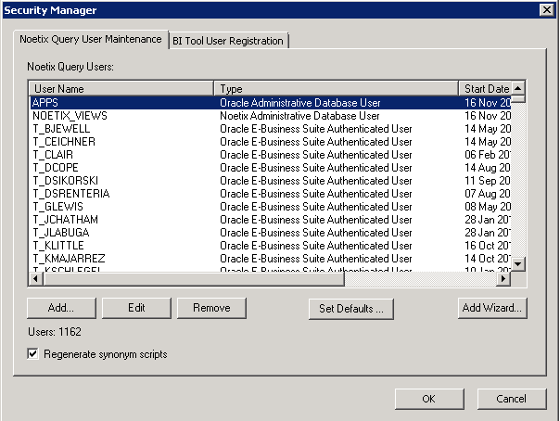

select * from N_SECURITY_MGR_USERS

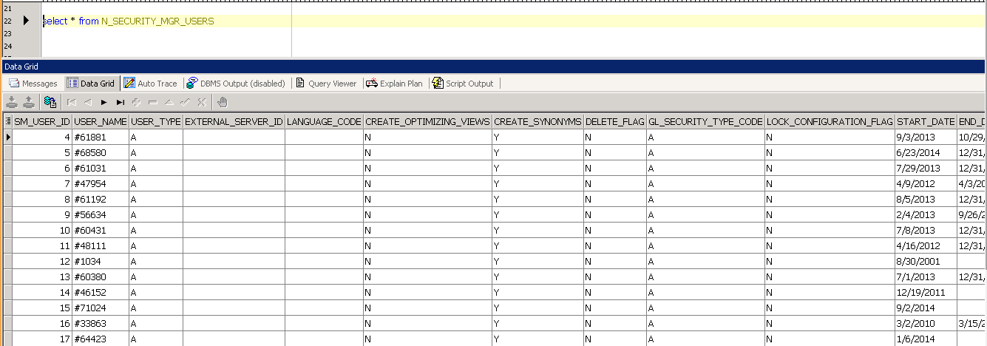

**Query User Types**

The following screen is different types of Noetix Query Users in Security Manager window.

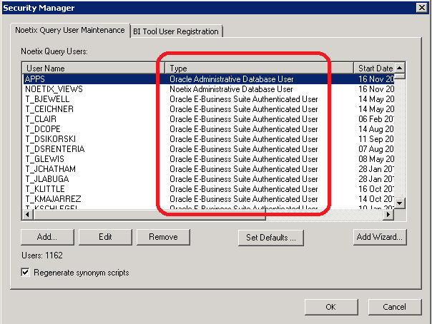

select * from N_SM_USER_TYPES

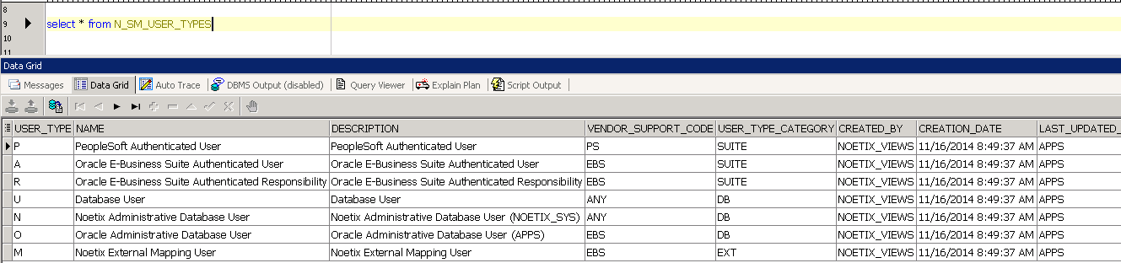

**Access Models**

The following screen is gives us different types of access modes in Security.

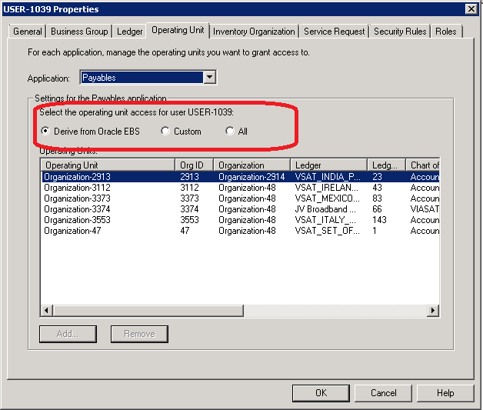

select * from N_SM_ACCESS_MODES

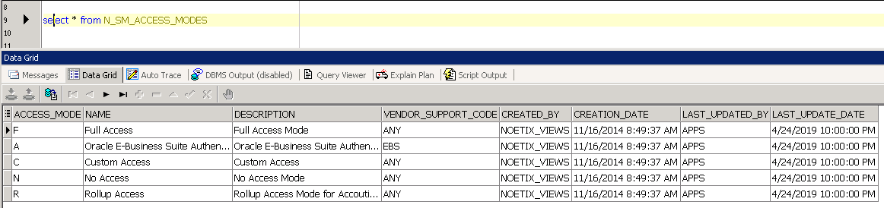

**Modules**

The following screen returns various modules like Payables, Receivables etc., installed in Viasat environment.

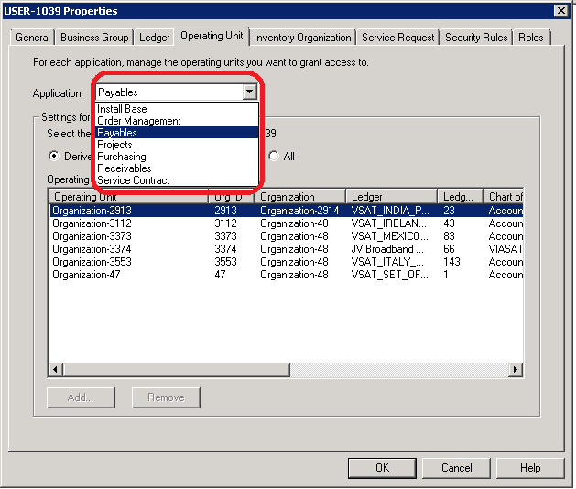

select * from N_SM_MODULES

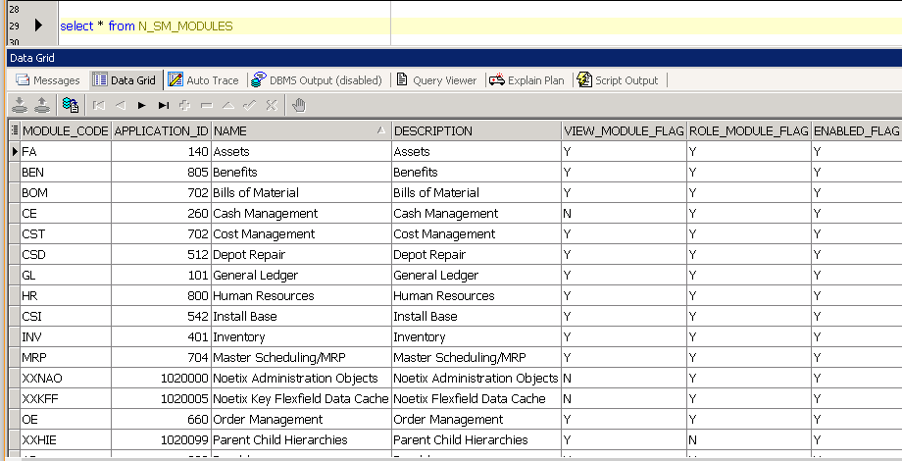

**Attribute Modules**

The following screen returns various types of attributes and its corresponding modules installed in Viasat environment.

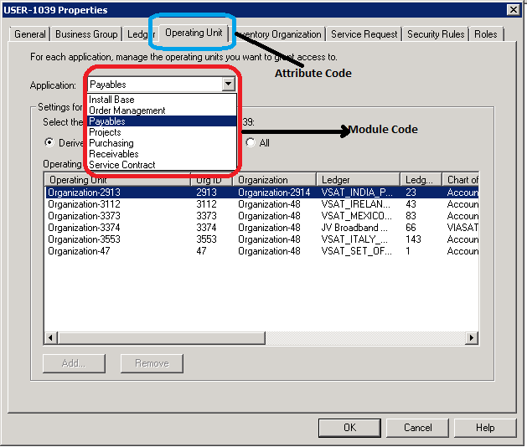

select * from N_SM_ATTRIBUTE_MODULES

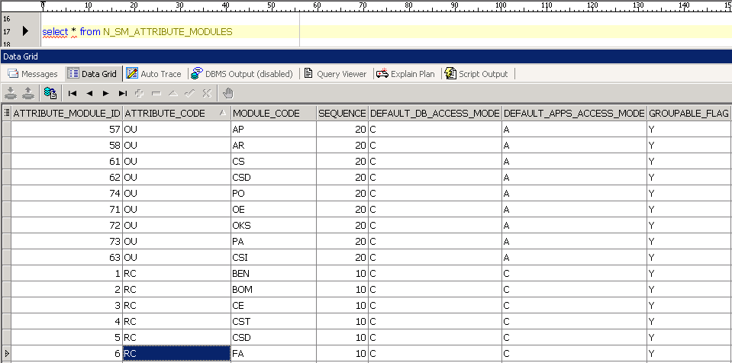

**Attribute Modes**

The following screen returns various attribute codes and its corresponding access modes

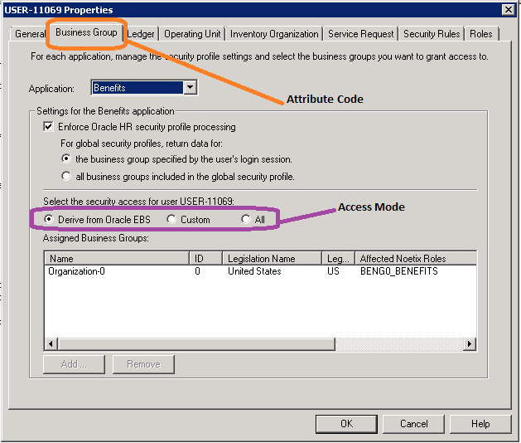

select * from N_SM_ATTRIBUTE_MODES

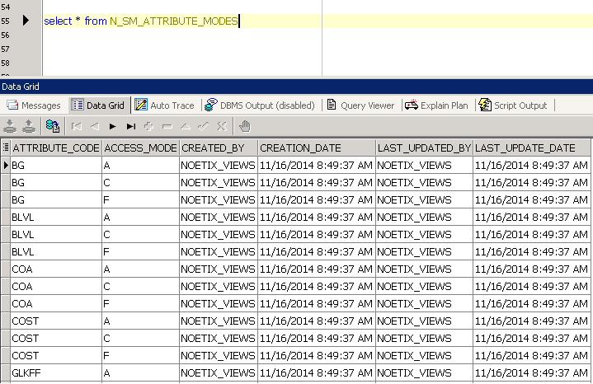

**User Attributes**

The following screen returns various attribute modules and its corressponding access modes.

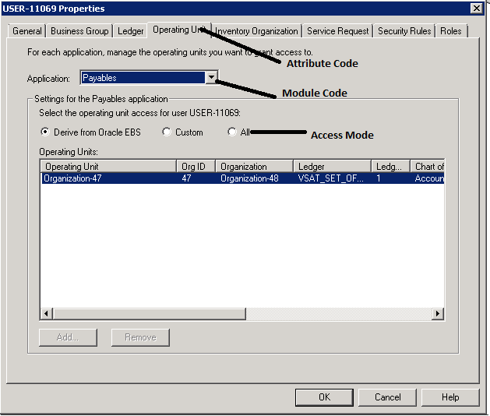

select * from N_SM_USER_ATTRIBUTES

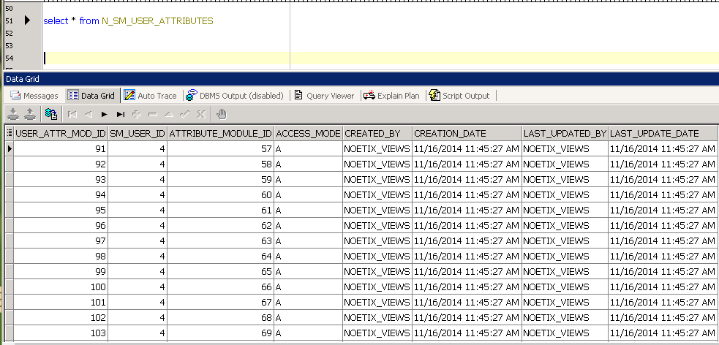

**Groups**

The following screen returns security manger groups. This table consists of all groups like users, responsibilities and access etc.,

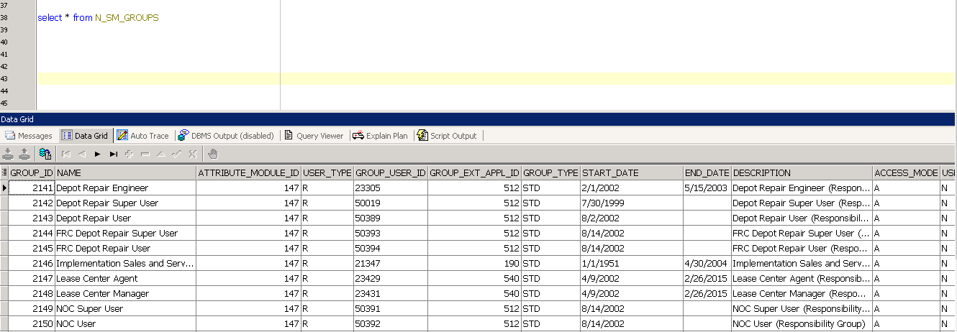

**Group List**

The following screen returns security manger group lists. This table consists relationship and combinational data between groups, properties and attribute modules.

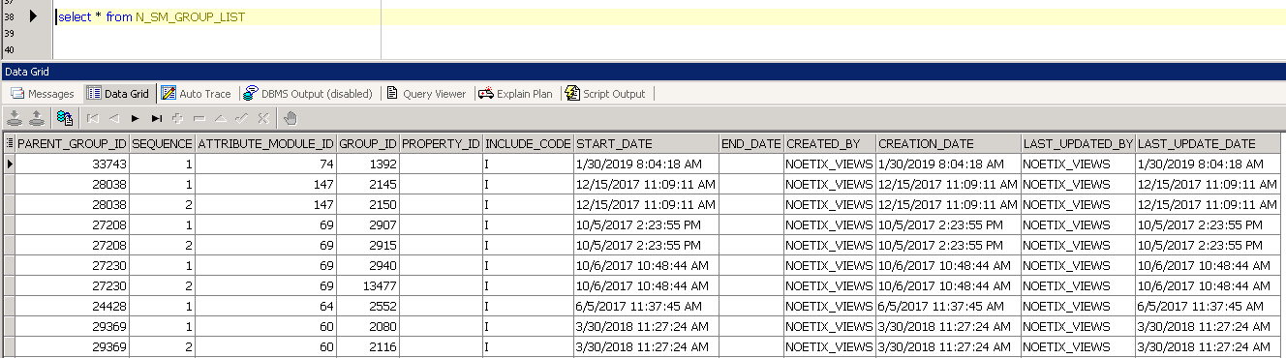

**Security Attributes**

The following screen returns various attributes codes and its security levels.

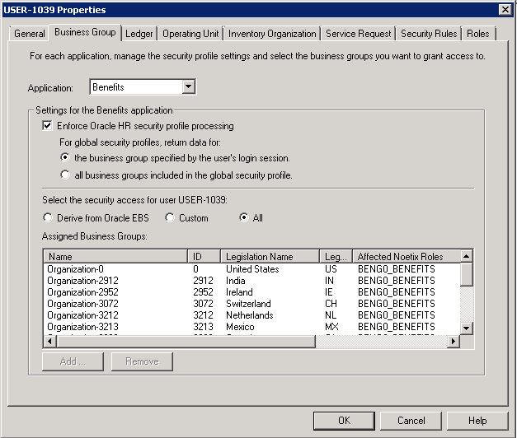

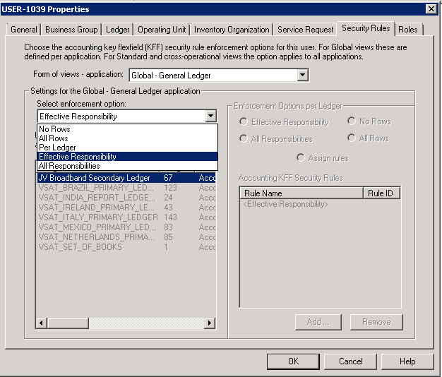

select * from N_SM_SECURITY_ATTRIBUTES

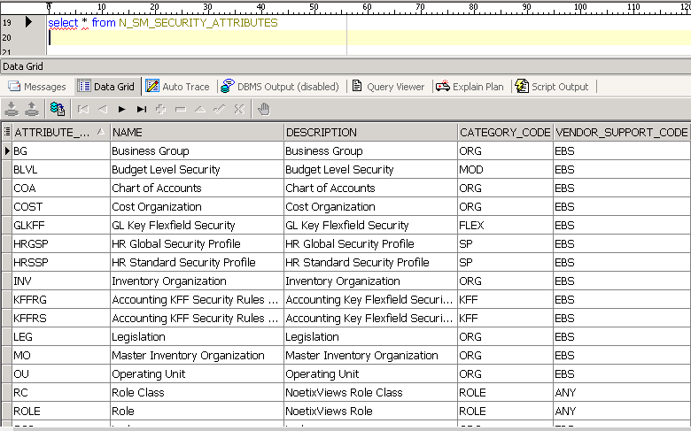

**Properties and Roles**

The following screen returns roles assigned to the Noetix Query Users.

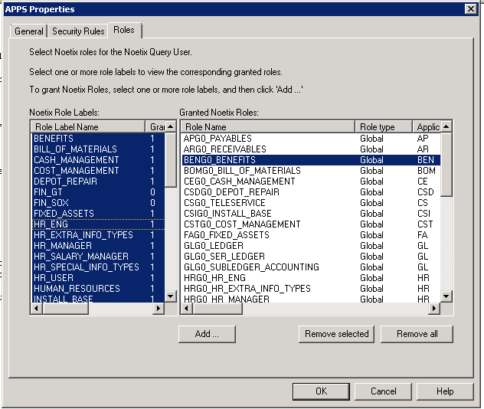

select * from N_SM_PROPERTIES where field1= 'ROLE_NAME'

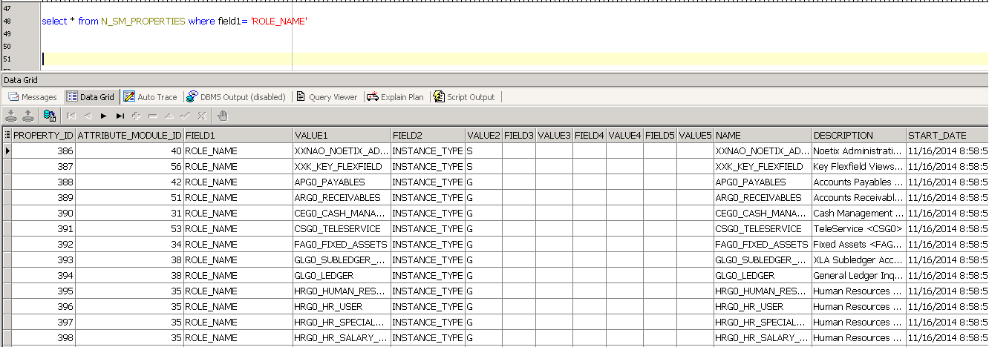

select * from N_SM_GRANTED_USER_ROLES

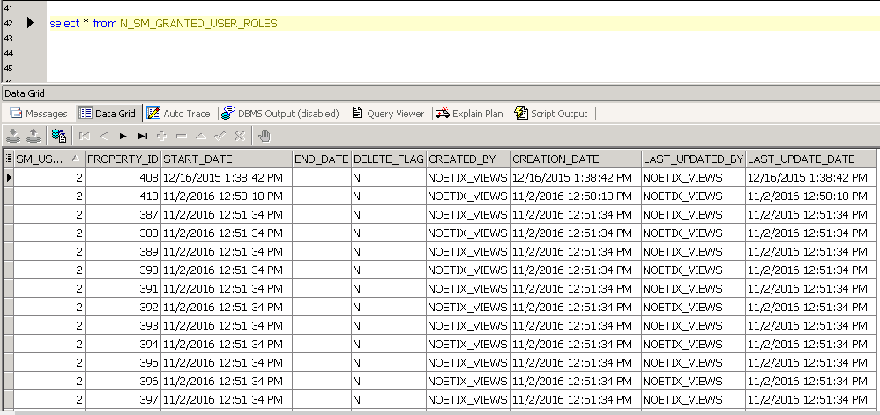

**User Authorizations**

**Group Authorizations**

The group authorizations table stores the relationship between groups and properties.

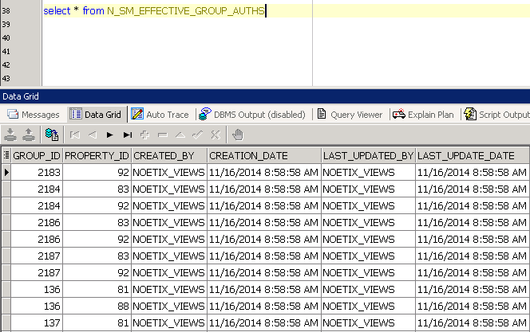

**Granted User Authorizations**

This table stores the relationship between user attribute module, group and properties.

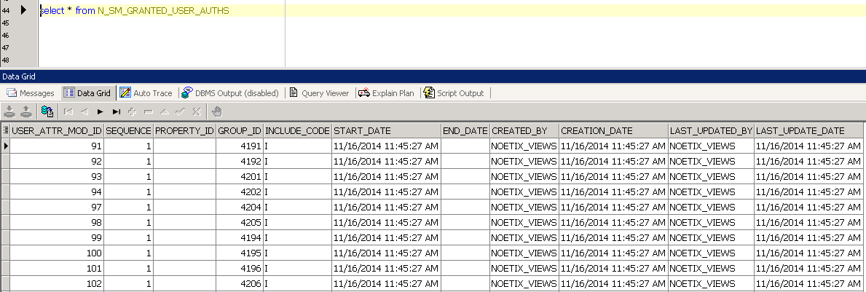

**Effective User Authorizations**

This table stores the relationship between user attribute module, users, properties, modules and access mode values.

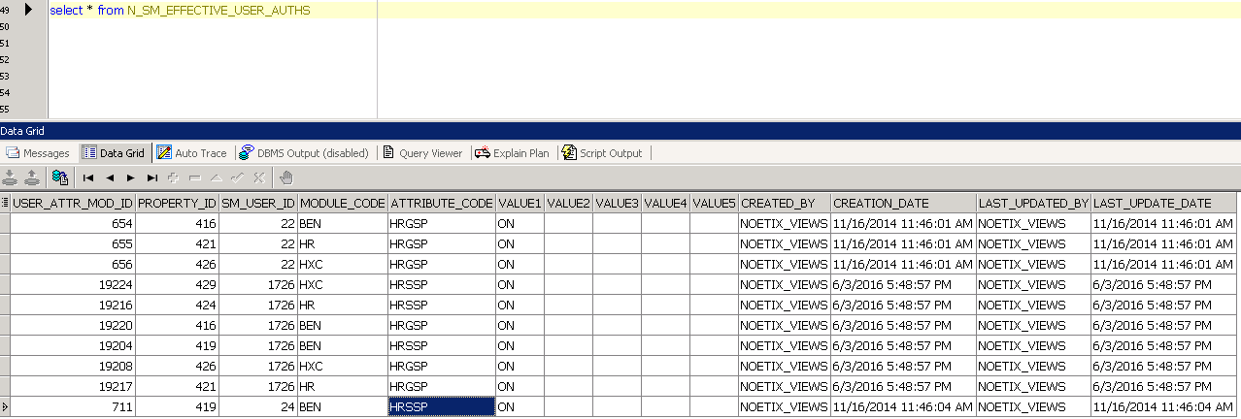

**BI Tool Registrations**

The following screen displays for installing a BI Tool.

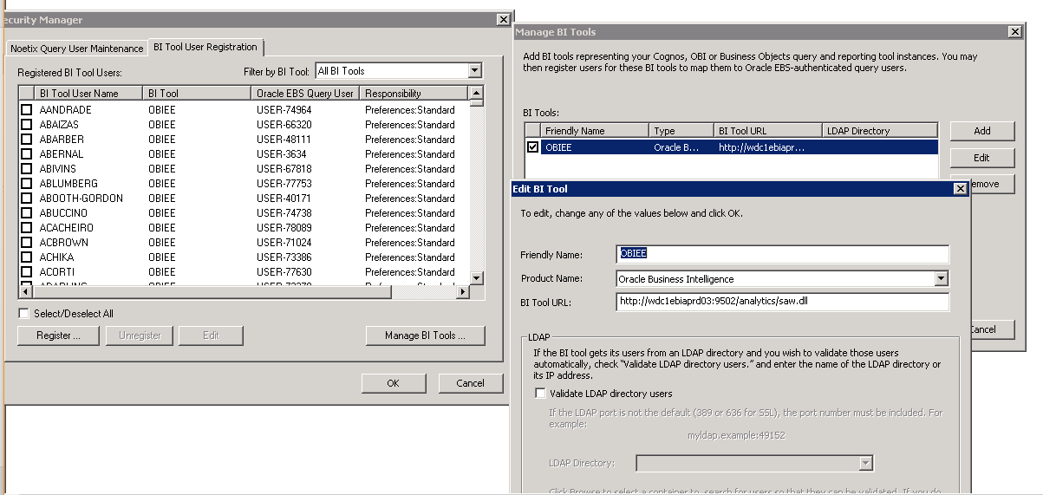

select * from N_SM_CONNECTIONS

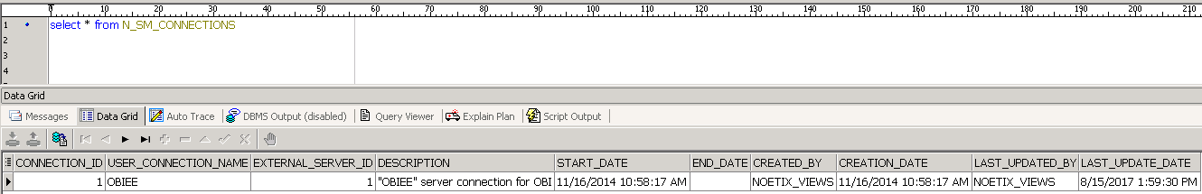

select * from N_SM_EXTERNAL­­_SERVERS

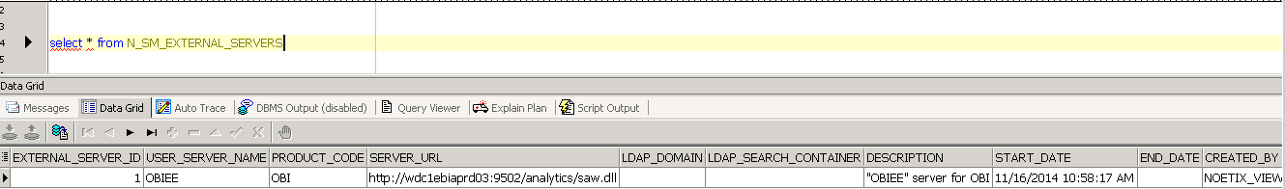

**BI User Registrations**

The following screen displays for registering a BI user.

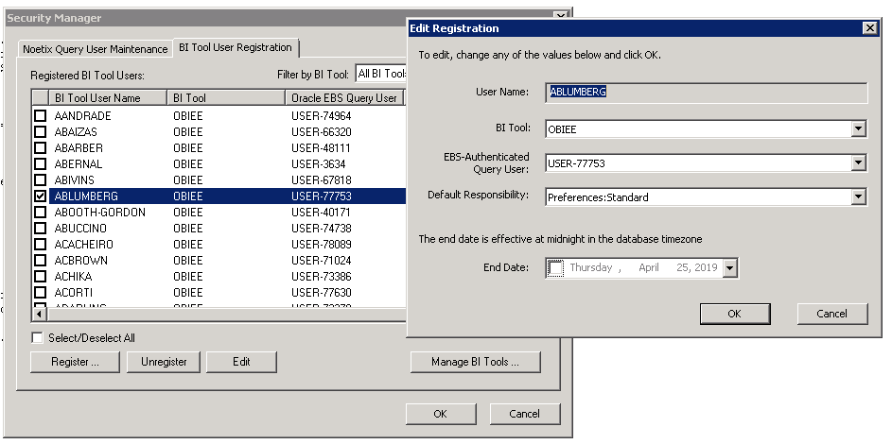

select * from N_SM_USER_CONNECTIONS

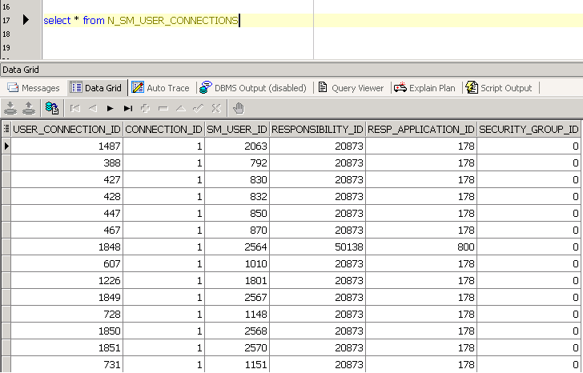

The below views are created based on the various tables created for Security Manager architecture.

CREATE OR REPLACE FORCE VIEW NOETIX_VIEWS.N_SM_USER_CONNECTIONS_V

(

SM_USER_ID,

USER_NAME,

USER_TYPE,

EXTERNAL_SERVER_ID,

EFFECTIVE_SM_USER_ID,

EFFECTIVE_EXTERNAL_USER_NAME,

EFFECTIVE_USER_NAME,

EFFECTIVE_USER_TYPE,

EFFECTIVE_FND_USER_ID,

CREATE_OPTIMIZING_VIEWS,

CREATE_SYNONYMS,

DELETE_FLAG,

SELF_REGISTERED_FLAG,

USER_START_DATE,

USER_END_DATE,

USER_CREATED_BY,

USER_CREATION_DATE,

USER_LAST_UPDATED_BY,

USER_LAST_UPDATE_DATE,

USER_SERVER_NAME,

PRODUCT_CODE,

SERVER_URL,

LDAP_DOMAIN,

LDAP_SEARCH_CONTAINER,

SERVER_DESCRIPTION,

SERVER_START_DATE,

SERVER_END_DATE,

SERVER_CREATED_BY,

SERVER_CREATION_DATE,

SERVER_LAST_UPDATED_BY,

SERVER_LAST_UPDATE_DATE,

CONNECTION_ID,

USER_CONNECTION_NAME,

CONNECTION_DESCRIPTION,

CONNECTION_START_DATE,

CONNECTION_END_DATE,

CONNECTION_CREATED_BY,

CONNECTION_CREATION_DATE,

CONNECTION_LAST_UPDATED_BY,

CONNECTION_LAST_UPDATE_DATE,

USER_CONNECTION_ID,

RESPONSIBILITY_ID,

RESP_APPLICATION_ID,

SECURITY_GROUP_ID,

RESPONSIBILITY_NAME,

SECURITY_GROUP_NAME,

RESP_SEC_GROUP_NAME

)

AS

SELECT ext.sm_user_id,

ext.user_name,

ext.user_type,

ext.external_server_id,

ext.effective_sm_user_id,

ext.effective_external_user_name,

ext.effective_user_name,

ext.effective_user_type,

ext.effective_fnd_user_id,

ext.create_optimizing_views,

ext.create_synonyms,

ext.delete_flag,

ext.self_registered_flag,

ext.user_start_date,

ext.user_end_date,

ext.user_created_by,

ext.user_creation_date,

ext.user_last_updated_by,

ext.user_last_update_date,

ext.user_server_name,

ext.product_code,

ext.server_url,

ext.ldap_domain,

ext.ldap_search_container,

ext.server_description,

ext.server_start_date,

ext.server_end_date,

ext.server_created_by,

ext.server_creation_date,

ext.server_last_updated_by,

ext.server_last_update_date,

ext.connection_id,

ext.user_connection_name,

ext.connection_description,

ext.connection_start_date,

ext.connection_end_date,

ext.connection_created_by,

ext.connection_creation_date,

ext.connection_last_updated_by,

ext.connection_last_update_date,

ext.user_connection_id,

ext.responsibility_id,

ext.resp_application_id,

ext.security_group_id,

r.responsibility_name,

s.security_group_name,

r.responsibility_name

|| (CASE APPS.XXNAO_FND_WRAPPER_PKG.Are_Security_Groups_Enabled

WHEN 'Y' THEN ':' || s.security_group_name

ELSE TO_CHAR (NULL)

END)

resp_sec_group_name

FROM n_fnd_security_groups_vl s,

n_fnd_responsibility_vl r,

n_sm_user_connections_base_v ext

WHERE r.responsibility_id(+) = ext.responsibility_id

AND r.application_id(+) = ext.resp_application_id

AND s.security_group_id(+) = ext.security_group_id;

CREATE OR REPLACE FORCE VIEW NOETIX_VIEWS.N_SM_USER_CONNECTIONS_BASE_V

(

SM_USER_ID,

USER_NAME,

USER_TYPE,

EXTERNAL_SERVER_ID,

EFFECTIVE_SM_USER_ID,

EFFECTIVE_EXTERNAL_USER_NAME,

EFFECTIVE_USER_NAME,

EFFECTIVE_USER_TYPE,

EFFECTIVE_FND_USER_ID,

CREATE_OPTIMIZING_VIEWS,

CREATE_SYNONYMS,

DELETE_FLAG,

SELF_REGISTERED_FLAG,

USER_START_DATE,

USER_END_DATE,

USER_CREATED_BY,

USER_CREATION_DATE,

USER_LAST_UPDATED_BY,

USER_LAST_UPDATE_DATE,

USER_SERVER_NAME,

PRODUCT_CODE,

SERVER_URL,

LDAP_DOMAIN,

LDAP_SEARCH_CONTAINER,

SERVER_DESCRIPTION,

SERVER_START_DATE,

SERVER_END_DATE,

SERVER_CREATED_BY,

SERVER_CREATION_DATE,

SERVER_LAST_UPDATED_BY,

SERVER_LAST_UPDATE_DATE,

CONNECTION_ID,

USER_CONNECTION_NAME,

CONNECTION_DESCRIPTION,

CONNECTION_START_DATE,

CONNECTION_END_DATE,

CONNECTION_CREATED_BY,

CONNECTION_CREATION_DATE,

CONNECTION_LAST_UPDATED_BY,

CONNECTION_LAST_UPDATE_DATE,

USER_CONNECTION_ID,

RESPONSIBILITY_ID,

RESP_APPLICATION_ID,

SECURITY_GROUP_ID

)

AS

SELECT ext.sm_user_id,

ext.user_name,

ext.user_type,

ext.external_server_id,

ext.effective_sm_user_id,

NVL (eff.external_user_name, eff.user_name)

effective_external_user_name,

eff.user_name effective_user_name,

eff.user_type effective_user_type,

(CASE eff.user_type WHEN 'A' THEN eff.external_id ELSE NULL END)

effective_fnd_user_id,

ext.create_optimizing_views,

ext.create_synonyms,

ext.delete_flag,

ext.self_registered_flag,

ext.start_date user_start_date,

ext.end_date user_end_date,

ext.created_by user_created_by,

ext.creation_date user_creation_date,

ext.last_updated_by user_last_updated_by,

ext.last_update_date user_last_update_date,

c.user_server_name,

c.product_code,

c.server_url,

c.ldap_domain,

c.ldap_search_container,

c.description server_description,

c.start_date server_start_date,

c.end_date server_end_date,

c.created_by server_created_by,

c.creation_date server_creation_date,

c.last_updated_by server_last_updated_by,

c.last_update_date server_last_update_date,

c.connection_id,

c.user_connection_name,

c.connection_description,

c.connection_start_date,

c.connection_end_date,

c.connection_created_by,

c.connection_creation_date,

c.connection_last_updated_by,

c.connection_last_update_date,

u.user_connection_id,

u.responsibility_id,

u.resp_application_id,

u.security_group_id

FROM n_sm_server_connections_v c,

n_sm_user_connections u,

n_security_mgr_users eff,

n_security_mgr_users ext

WHERE ext.user_type = 'M'

AND eff.sm_user_id(+) = ext.effective_sm_user_id

AND u.sm_user_id = ext.sm_user_id

AND c.external_server_id = ext.external_server_id

AND c.connection_id = u.connection_id;

CREATE OR REPLACE FORCE VIEW NOETIX_VIEWS.N_SM_GRANTED_USER_ROLES_V

(

SM_USER_ID,

PROPERTY_ID,

START_DATE,

END_DATE,

DELETE_FLAG,

CREATED_BY,

CREATION_DATE,

LAST_UPDATED_BY,

LAST_UPDATE_DATE,

USER_NAME,

USER_TYPE,

USER_START_DATE,

USER_END_DATE,

USER_EXTERNAL_USER_NAME,

USER_EXTERNAL_ID,

USER_EXTERNAL_APPL_ID,

ATTRIBUTE_CATEGORY_CODE,

ATTRIBUTE_CODE,

MODULE_CODE,

PROPERTY_ATTRIBUTE_MODULE_ID,

ROLE_NAME,

PROPERTY_NAME,

PROPERTY_FIELD1,

PROPERTY_VALUE1,

PROPERTY_FIELD2,

PROPERTY_VALUE2,

PROPERTY_FIELD3,

PROPERTY_VALUE3,

PROPERTY_FIELD4,

PROPERTY_VALUE4,

PROPERTY_FIELD5,

PROPERTY_VALUE5,

PROPERTY_PARENT_PROP_ID,

PROPERTY_START_DATE,

PROPERTY_END_DATE

)

AS

SELECT ur.sm_user_id,

ur.property_id,

ur.start_date,

ur.end_date,

ur.delete_flag,

ur.created_by,

ur.creation_date,

ur.last_updated_by,

ur.last_update_date,

u.user_name,

u.user_type,

u.start_date user_start_date,

u.end_date user_end_date,

u.external_user_name user_external_user_name,

u.external_id user_external_id,

u.external_application_id user_external_appl_id,

prop.attribute_category_code,

prop.attribute_code,

prop.module_code,

prop.attribute_module_id property_attribute_module_id,

prop.name role_name,

prop.name property_name,

prop.field1 property_field1,

prop.value1 property_value1,

prop.field2 property_field2,

prop.value2 property_value2,

prop.field3 property_field3,

prop.value3 property_value3,

prop.field4 property_field4,

prop.value4 property_value4,

prop.field5 property_field5,

prop.value5 property_value5,

prop.parent_property_id property_parent_prop_id,

prop.start_date property_start_date,

prop.end_date property_end_date

FROM n_sm_granted_user_roles ur,

n_security_mgr_users u,

n_sm_properties_v prop

WHERE ur.sm_user_id = u.sm_user_id AND ur.property_id = prop.property_id;

CREATE OR REPLACE FORCE VIEW NOETIX_VIEWS.N_SM_GRANTED_USER_AUTHS_V

(

USER_ATTR_MOD_ID,

SEQUENCE,

SM_USER_ID,

USER_NAME,

USER_TYPE,

USER_START_DATE,

USER_END_DATE,

USER_FND_USER_ID,

USER_RESPONSIBILITY_ID,

USER_RESP_APPL_ID,

ATTRIBUTE_MODULE_ID,

ATTRIBUTE_CODE,

ATTRIBUTE_NAME,

ATTRIBUTE_DESCRIPTION,

ATTR_MULTIPLE_VALUES_FLAG,

ATTRIBUTE_ENABLED_FLAG,

MODULE_CODE,

MODULE_NAME,

MODULE_DESCRIPTION,

MODULE_ENABLED_FLAG,

PROPERTY_ID,

PROPERTY_ATTRIBUTE_MODULE_ID,

PROPERTY_NAME,

PROPERTY_FIELD1,

PROPERTY_VALUE1,

PROPERTY_FIELD2,

PROPERTY_VALUE2,

PROPERTY_FIELD3,

PROPERTY_VALUE3,

PROPERTY_FIELD4,

PROPERTY_VALUE4,

PROPERTY_FIELD5,

PROPERTY_VALUE5,

PROPERTY_PARENT_PROP_ID,

GROUP_ID,

GROUP_NAME,

GROUP_TYPE,

GROUP_ATTRIBUTE_MODULE_ID,

GROUP_START_DATE,

GROUP_END_DATE,

GROUP_USER_TYPE,

GROUP_USER_ID,

GROUP_EXT_APPL_ID,

GROUP_USER_NAME,

FND_USER_ID,

RESPONSIBILITY_APPLICATION_ID,

RESPONSIBILITY_ID,

GROUP_USER_EDITABLE_FLAG,

INCLUDE_CODE,

START_DATE,

END_DATE

)

AS

SELECT auth.user_attr_mod_id,

auth.sequence,

uattr.sm_user_id,

usr.user_name,

usr.user_type,

usr.start_date user_start_date,

usr.end_date user_end_date,

(CASE usr.user_type WHEN 'A' THEN usr.external_id ELSE NULL END)

user_fnd_user_id,

(CASE usr.user_type WHEN 'R' THEN usr.external_id ELSE NULL END)

user_responsibility_id,

usr.external_application_id user_resp_appl_id,

uattr.attribute_module_id,

am.attribute_code,

am.attribute_name,

am.attribute_description,

am.attr_multiple_values_flag,

am.attribute_enabled_flag,

am.module_code,

am.module_name,

am.module_description,

am.module_enabled_flag,

auth.property_id,

prop.attribute_module_id property_attribute_module_id,

prop.name property_name,

prop.field1 property_field1,

prop.value1 property_value1,

prop.field2 property_field2,

prop.value2 property_value2,

prop.field3 property_field3,

prop.value3 property_value3,

prop.field4 property_field4,

prop.value4 property_value4,

prop.field5 property_field5,

prop.value5 property_value5,

prop.parent_property_id property_parent_prop_id,

auth.GROUP_ID,

grp.name group_name,

grp.group_type group_type,

grp.attribute_module_id group_attribute_module_id,

grp.start_date group_start_date,

grp.end_date group_end_date,

grp.user_type GROUP_USER_TYPE,

grp.group_user_id,

grp.group_ext_appl_id,

(CASE grp.user_type WHEN 'U' THEN grp.group_user_id ELSE NULL END)

GROUP_USER_NAME,

(CASE grp.user_type WHEN 'A' THEN grp.group_user_id ELSE NULL END)

fnd_user_id,

(CASE grp.user_type

WHEN 'R' THEN grp.group_ext_appl_id

ELSE NULL

END)

responsibility_application_id,

(CASE grp.user_type WHEN 'R' THEN grp.group_user_id ELSE NULL END)

responsibility_id,

grp.user_editable_flag group_user_editable_flag,

auth.include_code,

auth.start_date,

auth.end_date

FROM n_sm_groups grp,

n_sm_properties prop,

n_sm_attribute_modules_v am,

n_security_mgr_users usr,

n_sm_user_attributes uattr,

n_sm_granted_user_auths auth

WHERE uattr.user_attr_mod_id = auth.user_attr_mod_id

AND usr.sm_user_id = uattr.sm_user_id

AND usr.user_type <> 'M'

AND am.attribute_module_id = uattr.attribute_module_id

AND prop.property_id(+) = auth.property_id

AND grp.GROUP_ID(+) = auth.GROUP_ID;

CREATE OR REPLACE FORCE VIEW NOETIX_VIEWS.N_SM_EFF_USER_GEN_AUTHS_V

(

USER_ATTR_MOD_ID,

ACCESS_MODE,

SEQUENCE,

INCLUDE_CODE,

SM_USER_ID,

ATTRIBUTE_MODULE_ID,

ATTRIBUTE_CODE,

MODULE_CODE,

CATEGORY_CODE,

MULTIPLE_VALUES_FLAG,

GROUP_ID,

GROUP_NAME,

GROUP_USER_TYPE,

GROUP_USER_ID,

GROUP_EXT_APPL_ID,

GROUP_TYPE,

PROPERTY_ID,

PROPERTY_NAME,

FIELD1,

VALUE1,

FIELD2,

VALUE2,

FIELD3,

VALUE3,

FIELD4,

VALUE4,

FIELD5,

VALUE5,

PARENT_PROPERTY_ID

)

AS

SELECT ua.user_attr_mod_id,

ua.access_mode,

ugrnt.sequence,

ugrnt.include_code,

ua.sm_user_id,

ua.attribute_module_id,

am.attribute_code,

am.module_code,

attr.category_code,

attr.multiple_values_flag,

grp.GROUP_ID,

grp.name group_name,

grp.user_type group_user_type,

grp.group_user_id,

grp.GROUP_EXT_APPL_ID,

grp.group_type,

prop.property_id,

prop.name property_name,

prop.field1,

prop.value1,

prop.field2,

prop.value2,

prop.field3,

prop.value3,

prop.field4,

prop.value4,

prop.field5,

prop.value5,

prop.parent_property_id

FROM n_sm_properties prop,

n_sm_effective_group_auths gauth,

n_sm_groups grp,

n_sm_granted_user_auths ugrnt,

n_sm_modules MOD,

n_sm_security_attributes attr,

n_sm_attribute_modules am,

n_sm_user_attributes ua

WHERE am.attribute_module_id = ua.attribute_module_id

AND attr.attribute_code = am.attribute_code

AND (CASE am.attribute_code

WHEN 'KFFRG'

THEN

(CASE grp.access_mode WHEN 'N' THEN '-999.999' WHEN 'F' THEN '-888.888' END)

WHEN 'KFFRS'

THEN

(CASE grp.access_mode WHEN 'N' THEN '-999.999' WHEN 'F' THEN '-888.888' END)

ELSE

prop.value1

END) = prop.value1

AND NVL (attr.enabled_flag, 'N') = 'Y'

AND MOD.module_code = am.module_code

AND NVL (MOD.enabled_flag, 'N') = 'Y'

AND ugrnt.user_attr_mod_id = ua.user_attr_mod_id

AND SYSDATE BETWEEN ugrnt.start_date

AND NVL (ugrnt.end_date, SYSDATE + 1)

AND grp.GROUP_ID = ugrnt.GROUP_ID

AND SYSDATE BETWEEN grp.start_date

AND NVL (grp.end_date, SYSDATE + 1)

AND gauth.GROUP_ID = grp.GROUP_ID

AND prop.property_id = gauth.property_id

AND SYSDATE BETWEEN prop.start_date

AND NVL (prop.end_date, SYSDATE + 1)

UNION ALL

SELECT ua.user_attr_mod_id,

ua.access_mode,

ugrnt.sequence,

ugrnt.include_code,

ua.sm_user_id,

ua.attribute_module_id,

am.attribute_code,

am.module_code,

attr.category_code,

attr.multiple_values_flag,

NULL GROUP_ID,

NULL group_name,

NULL group_user_type,

NULL group_user_id,

NULL GROUP_EXT_APPL_ID,

NULL group_type,

prop.property_id,

prop.name property_name,

prop.field1,

prop.value1,

prop.field2,

prop.value2,

prop.field3,

prop.value3,

prop.field4,

prop.value4,

prop.field5,

prop.value5,

prop.parent_property_id

FROM n_sm_properties prop,

n_sm_granted_user_auths ugrnt,

n_sm_modules MOD,

n_sm_security_attributes attr,

n_sm_attribute_modules am,

n_sm_user_attributes ua

WHERE am.attribute_module_id = ua.attribute_module_id

AND attr.attribute_code = am.attribute_code

AND NVL (attr.enabled_flag, 'N') = 'Y'

AND MOD.module_code = am.module_code

AND NVL (MOD.enabled_flag, 'N') = 'Y'

AND ugrnt.user_attr_mod_id = ua.user_attr_mod_id

AND SYSDATE BETWEEN ugrnt.start_date

AND NVL (ugrnt.end_date, SYSDATE + 1)

AND prop.property_id = ugrnt.property_id

AND SYSDATE BETWEEN prop.start_date

AND NVL (prop.end_date, SYSDATE + 1);

CREATE OR REPLACE FORCE VIEW NOETIX_VIEWS.N_SM_EFF_USER_AUTHS_V

(

USER_ATTR_MOD_ID,

PROPERTY_ID,

SM_USER_ID,

USER_NAME,

USER_TYPE,

USER_START_DATE,

USER_END_DATE,

FND_USER_ID,

RESPONSIBILITY_ID,

RESP_APPLICATION_ID,

ATTRIBUTE_MODULE_ID,

ATTRIBUTE_CODE,

ATTR_MULTIPLE_VALUES_FLAG,

ATTRIBUTE_CATEGORY_CODE,

MODULE_CODE,

PROPERTY_NAME,

PROPERTY_DESCRIPTION,

FIELD1,

VALUE1,

FIELD2,

VALUE2,

FIELD3,

VALUE3,

FIELD4,

VALUE4,

FIELD5,

VALUE5,

PARENT_PROPERTY_ID,

PROP_START_DATE,

PROP_END_DATE

)

AS

SELECT uauth.user_attr_mod_id,

uauth.property_id,

uauth.sm_user_id,

usr.user_name,

usr.user_type,

usr.start_date user_start_date,

usr.end_date user_end_date,

(CASE usr.user_type WHEN 'A' THEN usr.external_id ELSE NULL END)

fnd_user_id,

(CASE usr.user_type WHEN 'R' THEN usr.external_id ELSE NULL END)

responsibility_id,

(CASE usr.user_type

WHEN 'R' THEN usr.external_application_id

ELSE NULL

END)

resp_application_id,

prop.attribute_module_id,

prop.attribute_code,

prop.attr_multiple_values_flag,

prop.attribute_category_code,

prop.module_code,

prop.name property_name,

prop.description property_description,

prop.field1,

uauth.value1,

prop.field2,

uauth.value2,

prop.field3,

uauth.value3,

prop.field4,

uauth.value4,

prop.field5,

uauth.value5,

prop.parent_property_id,

prop.start_date prop_start_date,

prop.end_date prop_end_date

FROM n_sm_properties_v prop,

n_security_mgr_users usr,

n_sm_effective_user_auths uauth

WHERE prop.property_id = uauth.property_id

AND usr.sm_user_id = uauth.sm_user_id

AND usr.user_type <> 'M';

CREATE OR REPLACE FORCE VIEW NOETIX_VIEWS.N_SM_APPS_USER_RESP_SG_V

(

USER_ID,

USER_NAME,

USER_RESP_START_DATE,

USER_RESP_END_DATE,

RESPONSIBILITY_ID,

APPLICATION_ID,

RESPONSIBILITY_NAME,

RESP_START_DATE,

RESP_END_DATE,

SECURITY_GROUP_ID,

SECURITY_GROUP_NAME,

RESP_SEC_GROUP_NAME

)

AS

SELECT sec.user_id,

sec.user_name,

sec.user_resp_start_date,

sec.user_resp_end_date,

sec.responsibility_id,

sec.application_id,

sec.responsibility_name,

sec.resp_start_date,

sec.resp_end_date,

sec.security_group_id,

sg.security_group_name,

sec.responsibility_name

|| (CASE APPS.XXNAO_FND_WRAPPER_PKG.Are_Security_Groups_Enabled

WHEN 'Y' THEN ':' || sg.security_group_name

ELSE TO_CHAR (NULL)

END)

resp_sec_group_name

FROM n_fnd_security_groups_vl sg, n_apps_security_info_vl sec

WHERE SYSDATE BETWEEN sec.user_resp_start_date

AND NVL (sec.user_resp_end_date, SYSDATE)

AND SYSDATE BETWEEN sec.resp_start_date

AND NVL (sec.resp_end_date, SYSDATE)

AND sg.security_group_id(+) = sec.security_group_id;

CREATE OR REPLACE FORCE VIEW NOETIX_VIEWS.N_SM_ALL_EFF_USER_AUTHS_V

(

USER_ATTR_MOD_ID,

PROPERTY_ID,

SM_USER_ID,

ACCESS_MODE,

USER_NAME,

USER_TYPE,

EXTERNAL_USER_NAME,

USER_START_DATE,

USER_END_DATE,

FND_USER_ID,

RESPONSIBILITY_ID,

RESP_APPLICATION_ID,

GROUP_ID,

GROUP_NAME,

GROUP_START_DATE,

GROUP_END_DATE,

ATTRIBUTE_MODULE_ID,

ATTRIBUTE_CODE,

ATTR_MULTIPLE_VALUES_FLAG,

ATTRIBUTE_CATEGORY_CODE,

MODULE_CODE,

PROPERTY_NAME,

PROPERTY_DESCRIPTION,

FIELD1,

VALUE1,

FIELD2,

VALUE2,

FIELD3,

VALUE3,

FIELD4,

VALUE4,

FIELD5,

VALUE5,

PARENT_PROPERTY_ID,

PROP_START_DATE,

PROP_END_DATE

)

AS

SELECT uauth.user_attr_mod_id,

uauth.property_id,

uauth.sm_user_id,

ua.access_mode,

usr.user_name,

usr.user_type,

usr.external_user_name,

usr.start_date user_start_date,

usr.end_date user_end_date,

(CASE usr.user_type WHEN 'A' THEN usr.external_id ELSE NULL END)

fnd_user_id,

(CASE usr.user_type WHEN 'R' THEN usr.external_id ELSE NULL END)

responsibility_id,

(CASE usr.user_type

WHEN 'R' THEN usr.external_application_id

ELSE NULL

END)

resp_application_id,

TO_NUMBER (NULL) GROUP_ID,

TO_CHAR (NULL) group_name,

TO_DATE (NULL) group_start_date,

TO_DATE (NULL) group_end_date,

prop.attribute_module_id,

prop.attribute_code,

prop.attr_multiple_values_flag,

prop.attribute_category_code,

prop.module_code,

prop.name property_name,

prop.description property_description,

prop.field1,

uauth.value1,

prop.field2,

uauth.value2,

prop.field3,

uauth.value3,

prop.field4,

uauth.value4,

prop.field5,

uauth.value5,

prop.parent_property_id,

prop.start_date prop_start_date,

prop.end_date prop_end_date

FROM n_sm_properties_v prop,

n_security_mgr_users usr,

n_sm_user_attributes ua,

n_sm_effective_user_auths uauth

WHERE prop.property_id = uauth.property_id

AND usr.sm_user_id = uauth.sm_user_id

AND ua.user_attr_mod_id = uauth.user_attr_mod_id

AND ua.sm_user_id = usr.sm_user_id

AND ua.attribute_module_id = prop.attribute_module_id

AND ua.access_mode = 'C'

AND usr.user_type <> 'M'

UNION ALL

SELECT ua.user_attr_mod_id,

ga.property_id,

ua.sm_user_id,

ua.access_mode access_mode,

usr.user_name,

usr.user_type,

usr.external_user_name,

usr.start_date user_start_date,

usr.end_date user_end_date,

(CASE usr.user_type WHEN 'A' THEN usr.external_id ELSE NULL END)

fnd_user_id,

(CASE usr.user_type WHEN 'R' THEN usr.external_id ELSE NULL END)

responsibility_id,

(CASE usr.user_type

WHEN 'R' THEN usr.external_application_id

ELSE NULL

END)

resp_application_id,

ga.GROUP_ID,

ga.group_name,

ga.group_start_date group_start_date,

ga.group_end_date group_end_date,

ga.prop_attribute_module_id attribute_module_id,

ga.prop_attribute_code attribute_code,

ga.attr_multiple_values_flag,

ga.prop_attribute_category_code attribute_category_code,

ga.prop_module_code module_code,

ga.prop_name property_name,

ga.prop_description property_description,

ga.field1,

ga.value1,

ga.field2,

ga.value2,

ga.field3,

ga.value3,

ga.field4,

ga.value4,

ga.field5,

ga.value5,

ga.parent_property_id,

ga.prop_start_date prop_start_date,

ga.prop_end_date prop_end_date

FROM n_security_mgr_users usr,

n_sm_user_attributes ua,

n_sm_eff_group_auths_v ga

WHERE usr.user_type IN ('A', 'R')

AND ua.sm_user_id = usr.sm_user_id

AND ga.group_attribute_module_id = ua.attribute_module_id

AND ga.group_access_mode = 'A'

AND ua.access_mode = 'A'

AND ga.group_access_mode = ua.access_mode

AND ga.group_attribute_code = ga.prop_attribute_code

AND ga.group_user_type IN ('A', 'R')

AND ( ( usr.user_type = 'A'

AND ga.group_external_id = usr.external_id

AND ga.group_external_application_id IS NULL)

OR (usr.user_type = 'R'

AND ga.group_external_id = usr.external_id

AND ga.group_external_application_id =

usr.external_application_id))

-- AND NVL(ga.value1,'NULLARG') <> '-9999'

AND ga.group_attribute_code = ga.prop_attribute_code

AND ga.group_module_code = ga.prop_module_code

AND ga.group_attribute_module_id = ga.prop_attribute_module_id

AND SYSDATE BETWEEN NVL (ga.group_start_date, SYSDATE)

AND NVL (ga.group_end_date, SYSDATE + 1)

AND SYSDATE BETWEEN NVL (ga.prop_start_date, SYSDATE)

AND NVL (ga.prop_end_date, SYSDATE + 1)

UNION ALL

SELECT ua.user_attr_mod_id,

ga.property_id,

ua.sm_user_id,

ua.access_mode access_mode,

usr.user_name,

usr.user_type,

usr.external_user_name,

usr.start_date user_start_date,

usr.end_date user_end_date,

(CASE usr.user_type WHEN 'A' THEN usr.external_id ELSE NULL END)

fnd_user_id,

(CASE usr.user_type WHEN 'R' THEN usr.external_id ELSE NULL END)

responsibility_id,

(CASE usr.user_type

WHEN 'R' THEN usr.external_application_id

ELSE NULL

END)

resp_application_id,

ga.GROUP_ID,

ga.group_name,

ga.group_start_date group_start_date,

ga.group_end_date group_end_date,

ga.prop_attribute_module_id attribute_module_id,

ga.prop_attribute_code attribute_code,

ga.attr_multiple_values_flag,

ga.prop_attribute_category_code attribute_category_code,

ga.prop_module_code module_code,

ga.prop_name property_name,

ga.prop_description property_description,

ga.field1,

ga.value1,

ga.field2,

ga.value2,

ga.field3,

ga.value3,

ga.field4,

ga.value4,

ga.field5,

ga.value5,

ga.parent_property_id,

ga.prop_start_date prop_start_date,

ga.prop_end_date prop_end_date

FROM n_security_mgr_users usr,

n_sm_user_attributes ua,

n_sm_eff_group_auths_v ga

WHERE usr.user_type <> 'M'

AND ua.sm_user_id = usr.sm_user_id

AND ga.group_attribute_module_id = ua.attribute_module_id

AND ga.group_access_mode = 'F'

AND ua.access_mode = 'F'

AND ga.group_access_mode = ua.access_mode

AND ga.group_attribute_code = ga.prop_attribute_code

AND ga.group_user_type IS NULL

-- AND NVL(ga.value1,'NULLARG') <> '-9999'

AND ga.group_attribute_code = ga.prop_attribute_code

AND ga.group_module_code = ga.prop_module_code

AND ga.group_attribute_module_id = ga.prop_attribute_module_id

AND SYSDATE BETWEEN NVL (ga.group_start_date, SYSDATE)

AND NVL (ga.group_end_date, SYSDATE + 1)

AND SYSDATE BETWEEN NVL (ga.prop_start_date, SYSDATE)

AND NVL (ga.prop_end_date, SYSDATE + 1);

CREATE OR REPLACE FORCE VIEW NOETIX_VIEWS.N_API_QUERY_USER_ROLES_V

(

USER_NAME,

ROLE_NAME

)

AS

SELECT --

qu.user_name, qur.role_name

FROM n_query_user_roles qur, n_query_users qu

WHERE qur.delete_flag = 'N'

AND qu.user_name = qur.user_name

AND qu.user_type NOT IN ('A', 'R', 'M')

--

UNION

SELECT rl.user_name, qur.role_name

FROM APPS.nv_nqs_responsibility_list rl,

n_query_users qu,

n_query_user_roles qur

WHERE qu.user_type = 'A'

AND qu.user_name = '#' || rl.user_id

AND qu.user_name = qur.user_name

AND qur.delete_flag = 'N'

UNION

SELECT rl.user_name, qur.role_name

FROM APPS.nv_nqs_responsibility_list rl,

n_query_users qu,

n_query_user_roles qur

WHERE qu.user_type = 'R'

AND qu.user_name =

'#' || rl.responsibility_id || '#' || rl.application_id

AND qu.user_name = qur.user_name

AND qur.delete_flag = 'N'

--

;

CREATE OR REPLACE FORCE VIEW NOETIX_VIEWS.N_API_QUERY_USERS_V

(

USER_NAME,

USER_TYPE

)

AS

SELECT user_name, user_type

FROM n_query_users

WHERE delete_flag = 'N' AND user_type NOT IN ('A', 'R', 'M')

--

UNION

SELECT rl.user_name, qu.user_type

FROM APPS.nv_nqs_responsibility_list rl, n_query_users qu

WHERE qu.user_type = 'A' AND qu.user_name = '#' || rl.user_id

UNION

SELECT rl.user_name, 'A'

FROM APPS.nv_nqs_responsibility_list rl, n_query_users qu

WHERE qu.user_type = 'R'

AND qu.user_name =

'#' || rl.responsibility_id || '#' || rl.application_id

--

;

CREATE OR REPLACE FORCE VIEW NOETIX_VIEWS.N_API_ORACLE_USERS_V

(USERNAME, READ_ONLY_FLAG, APPS_USER_FLAG)

AS

SELECT oracle_username,

read_only_flag,

case when read_only_flag in ('O','K','M','U')

then 'Y'

else 'N'

end apps_user_flag

-- NOTE: The fnd_oracle_userid synonym still exists in the 6.4.1 installer,

-- so there is no need to use the fnd_oracle_userid_s synonym. Makes

-- it compatible with earlier versions.

FROM fnd_oracle_userid

--

/* --

SELECT oprid,

'Y',

case when oprid = 'APPS'

then 'Y'

else 'N'

end apps_user_flag

FROM psoprdefn

WHERE acctlock = 0

UNION

SELECT 'APPS',

'Y',

'Y'

FROM dual

-- */

;

CREATE OR REPLACE FORCE VIEW NOETIX_VIEWS.N_API_MODULE_NAMES_V

(

APPLICATION_LABEL,

APPLICATION_SHORT_NAME,

MODULE_LONG_NAME

)

AS

SELECT application_label,

application_short_name,

NVL (

module_long_name,

DECODE (application_label,

'APPS', 'Oracle Applications',

'IFIN', 'Financial Interface',

'NOETIX', 'Noetix Objects',

'PBE', 'Projects - Billing Extension',

'PS', 'General Ledger (Public Sector)',

'XO', 'Cross Operation Extension',

'XXNAO', 'Noetix Administration',

'XXEIS', 'Noetix Administration',

application_label))

module_long_name

FROM n_api_appl_module_names_v;

CREATE OR REPLACE FORCE VIEW NOETIX_VIEWS.N_API_BI_USERS_V

(

SM_USER_ID,

USER_NAME,

MAPPED_USER_NAME,

MAPPED_SERVER_NAME,

SM_MAPPED_USER_ID,

SM_EXTERNAL_SERVER_ID,

EBS_USER_ID

)

AS

SELECT TO_NUMBER (NULL),

TO_CHAR (NULL),

TO_CHAR (NULL),

TO_CHAR (NULL),

TO_NUMBER (NULL),

TO_NUMBER (NULL),

TO_CHAR (NULL)

FROM DUAL

WHERE 1 = 0

--

UNION ALL

SELECT m.sm_user_id,

m.user_name,

a.external_user_name AS mapped_user_name,

s.user_server_name AS mapped_server_name,

a.sm_user_id AS sm_mapped_user_id,

s.external_server_id external_server_id,

a.external_id AS ebs_user_id

FROM n_security_mgr_users m

JOIN n_security_mgr_users a

ON m.effective_sm_user_id = a.sm_user_id

JOIN n_sm_external_servers s

ON s.external_server_id = m.external_server_id

WHERE m.user_type = 'M' AND a.user_type = 'A'